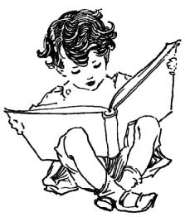

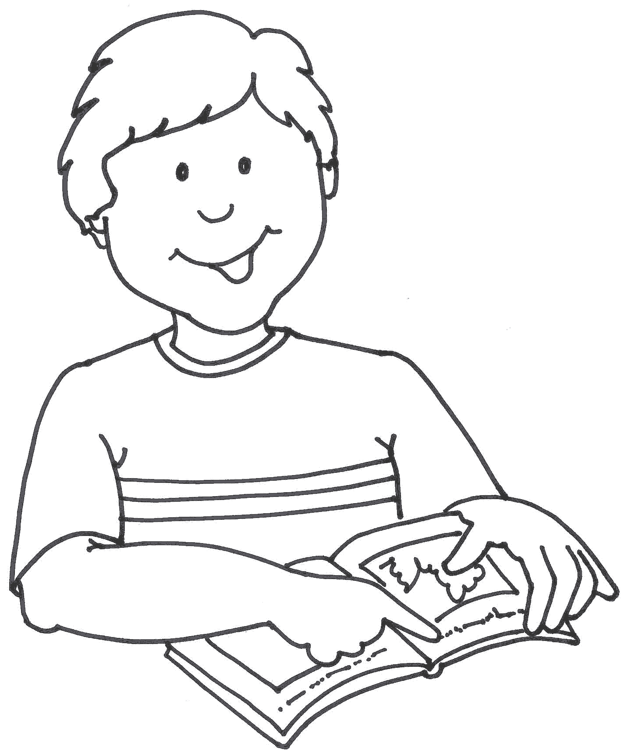

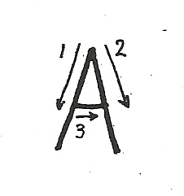

άλογο

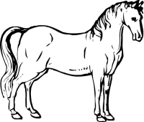

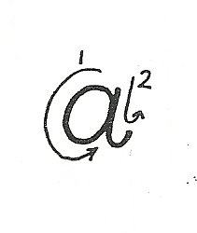

Α α, Α α, Α α, Α α, Α α, Α α, Α α

Α α, .........................................................................................
Α α, ........................................................................................
Α α, .......................................................................................

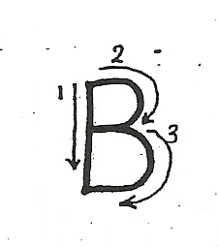
βαρέλι

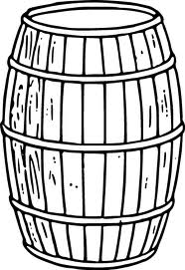

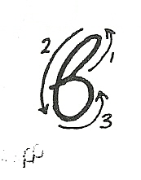

Β β, Β β, Β β, Β β, Β β, Β β, Β β

Β β, ........................................................................................
Β β, ........................................................................................
Β β, ........................................................................................

γάτα

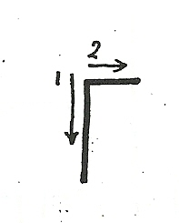

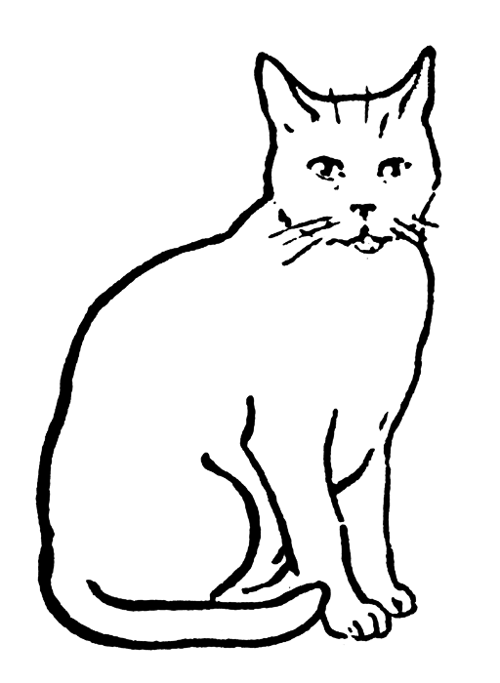

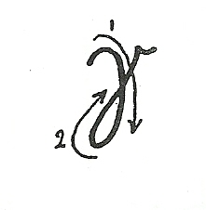

Γ γ, Γ γ, Γ γ, Γ γ, Γ γ, Γ γ, Γ γ

Γ γ, .......................................................................................
Γ γ, .......................................................................................
Γ γ, .......................................................................................

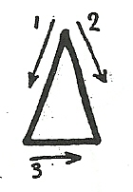
δώρο

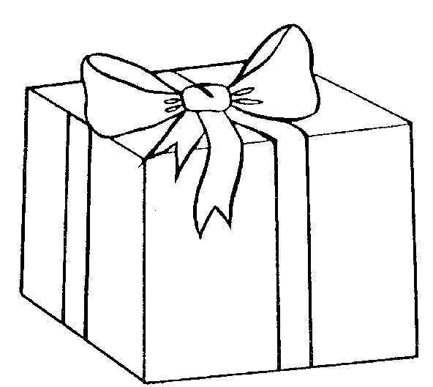

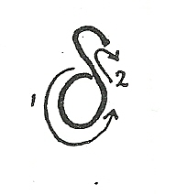

Δ δ, Δ δ, Δ δ, Δ δ, Δ δ, Δ δ, Δ δ

Δ δ, ........................................................................................
Δ δ, ........................................................................................
Δ δ, ........................................................................................

ελέφαντας
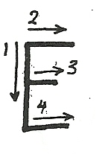

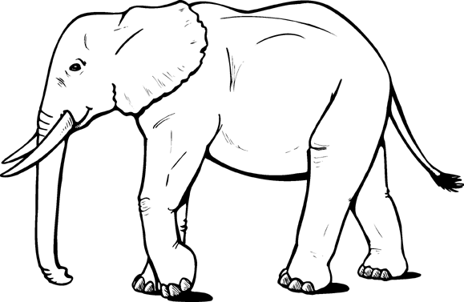

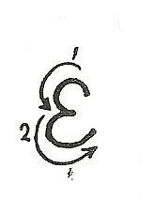

Ε ε, Ε ε, Ε ε, Ε ε, Ε ε, Ε ε, Ε ε

Ε ε, ........................................................................................
Ε ε, ........................................................................................
Ε ε, ........................................................................................

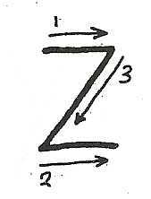
ζάρι

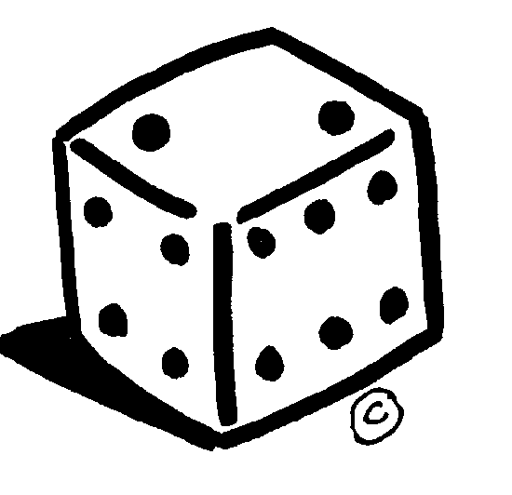

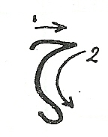

Ζ ζ, Ζ ζ, Ζ ζ, Ζ ζ, Ζ ζ, Ζ ζ, Ζ ζ

Ζ ζ, ........................................................................................
Ζ ζ, ........................................................................................
Ζ ζ, ........................................................................................

ήλιος

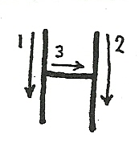

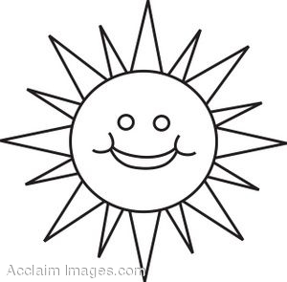

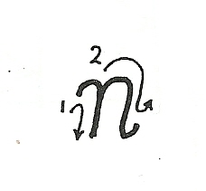

Η η, Η η, Η η, Η η, Η η, Η η, Η η

Η η, .......................................................................................
Η η, .......................................................................................
Η η, .......................................................................................

θάλασσα

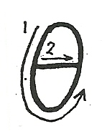

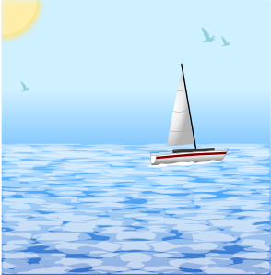

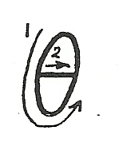

Θ θ, Θ θ, Θ θ, Θ θ, Θ θ, Θ θ, Θ θ

Θ θ, .......................................................................................
Θ θ, .......................................................................................
Θ θ, ........................................................................................

ινδιάνος

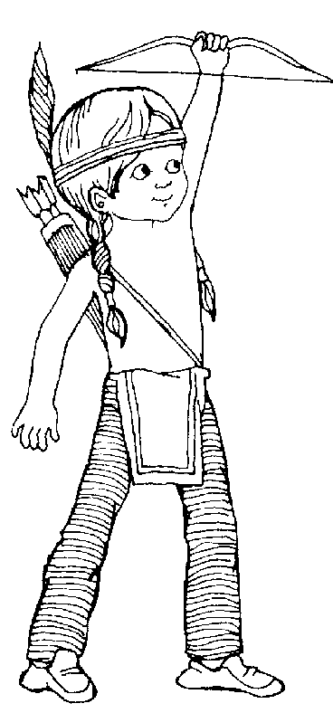

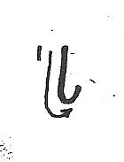

Ι ι, Ι ι, Ι ι, Ι ι, Ι ι, Ι ι, Ι ι I

Ι ι, ........................................................................................
Ι ι, ........................................................................................
Ι ι, ........................................................................................

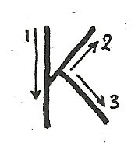
κότα

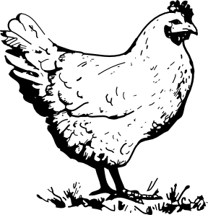

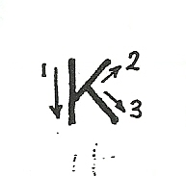

Κ κ, Κ κ, Κ κ, Κ κ, Κ κ, Κ κ, Κ κ

Κ κ, ........................................................................................
Κ κ, ........................................................................................
Κ κ, ........................................................................................

λεμόνι
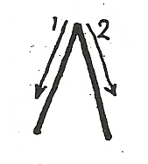

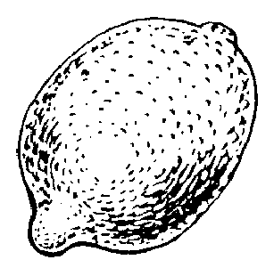

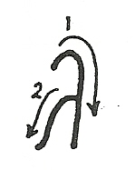

Λ λ, Λ λ, Λ λ, Λ λ, Λ λ, Λ λ, Λ λ

Λ λ, ........................................................................................
Λ λ, ........................................................................................

Λ λ, ........................................................................................

μολύβι
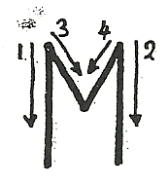

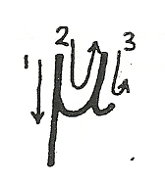

Μ μ, Μ μ, Μ μ, Μ μ, Μ μ, Μ μ, Μ μ

Μ μ, .......................................................................................
Μ μ, .......................................................................................
Μ μ, .......................................................................................

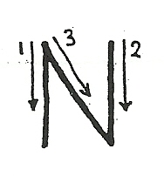
νερό

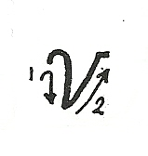

Ν ν, Ν ν, Ν ν, Ν ν, Ν ν, Ν ν, Ν ν

Ν ν, .......................................................................................
Ν ν, .......................................................................................
Ν ν, .......................................................................................

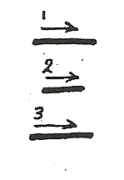
ξύλα

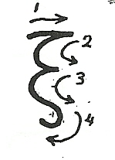

Ξ ξ, Ξ ξ, Ξ ξ, Ξ ξ, Ξ ξ, Ξ ξ, Ξ ξ

Ξ ξ, ........................................................................................
Ξ ξ, ........................................................................................
Ξ ξ, ........................................................................................

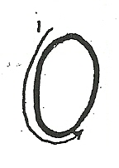
ομπρέλα

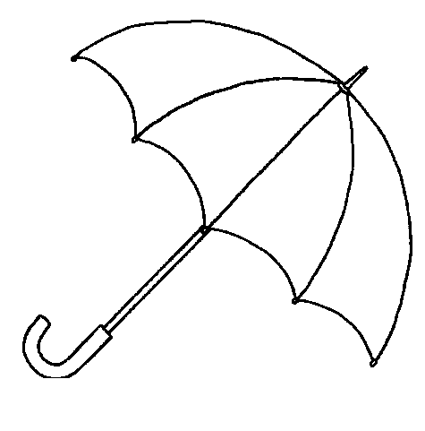

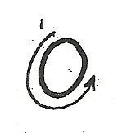

Ο ο, Ο ο, Ο ο, Ο ο, Ο ο, Ο ο, Ο ο

Ο ο, .......................................................................................
Ο ο, .......................................................................................
Ο ο, .......................................................................................

παγωτό
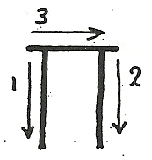

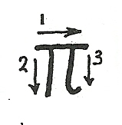

Π π, Π π, Π π, Π π, Π π, Π π, Π π

Π π, .......................................................................................
Π π, ........................................................................................
Π π, .......................................................................................

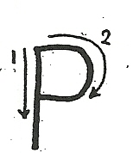
ράδιο

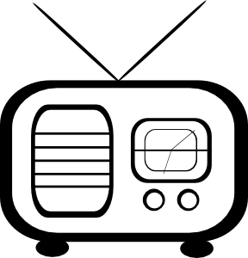

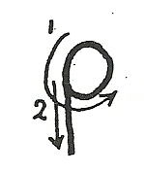

Ρ ρ, Ρ ρ, Ρ ρ, Ρ ρ, Ρ ρ, Ρ ρ, Ρρ

Ρ ρ, ........................................................................................
Ρ ρ, ........................................................................................
Ρ ρ, ........................................................................................

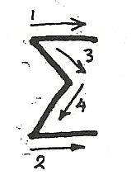
σκύλος

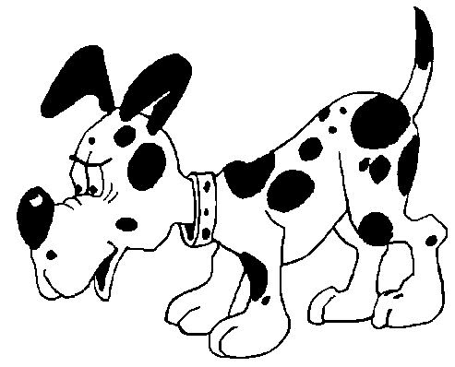

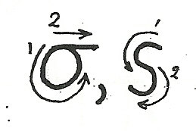

Σ σ ς, Σ σ ς, Σ σ ς, Σ σ ς, Σ σ ς, Σ σ ς

Σ σ ς, ....................................................................................
Σ σ ς, ....................................................................................
Σ σ ς, ....................................................................................

τηλέφωνο
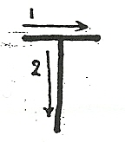

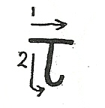

Τ τ, Τ τ, Τ τ, Τ τ, Τ τ, Τ τ, Τ τ

Τ τ, .......................................................................................
Τ τ, .......................................................................................
Τ τ, ......................................................................................

ύφασμα
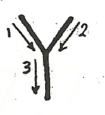

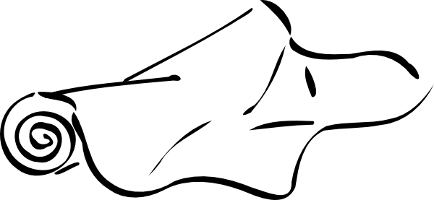

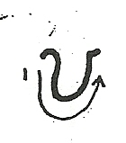

Υ υ, Υ υ, Υ υ, Υ υ, Υ υ, Υ υ, Υ υ

Υ υ, .......................................................................................
Υ υ, .......................................................................................
Υ υ, .......................................................................................

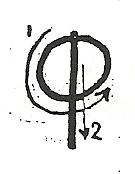
φίδι

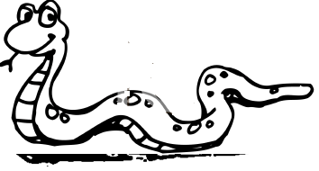

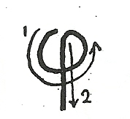

Φ φ, Φ φ, Φ φ, Φ φ, Φ φ, Φ φ, Φ φ

Φ φ, ........................................................................................
Φ φ, ........................................................................................
Φ φ, ........................................................................................

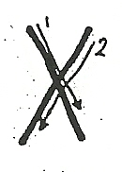
χελώνα

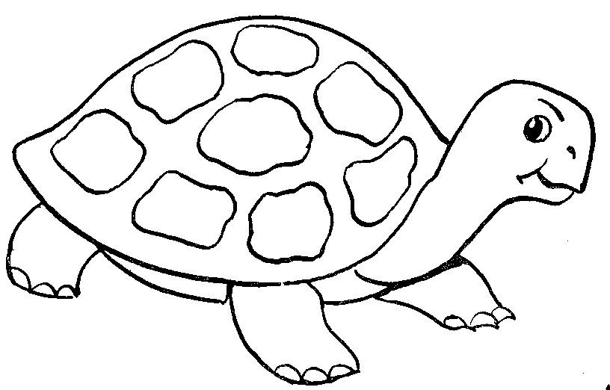

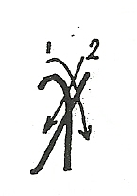

Χχ, Χ χ, Χ χ, Χ χ, Χ χ, Χ χ, Χ χ

Χ χ, .......................................................................................
Χ χ, .......................................................................................
Χ χ, .......................................................................................

ψάρι
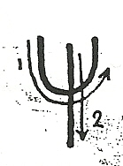

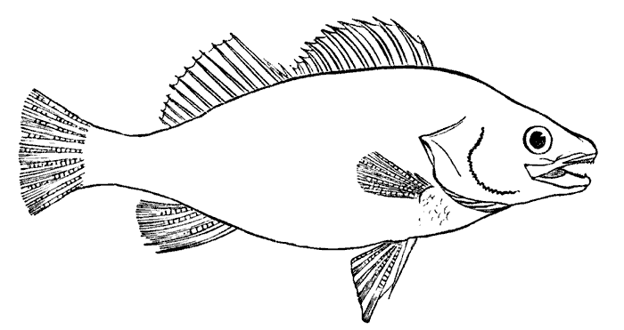

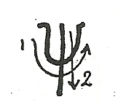

Ψ ψ, Ψ ψ, Ψ ψ, Ψ ψ, Ψ ψ, Ψ ψ, Ψ ψ

Ψ ψ, .......................................................................................
Ψ ψ, .......................................................................................
Ψ ψ, .......................................................................................

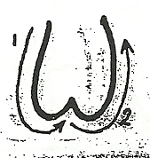
ώρα

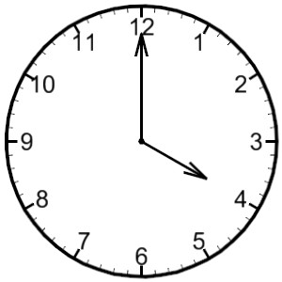

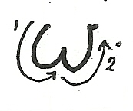

Ω ω, Ω ω, Ω ω, Ω ω, Ω ω, Ω ω, Ω ω

Ω ω, .....................................................................................
Ω ω, .....................................................................................
Ω ω, .....................................................................................

